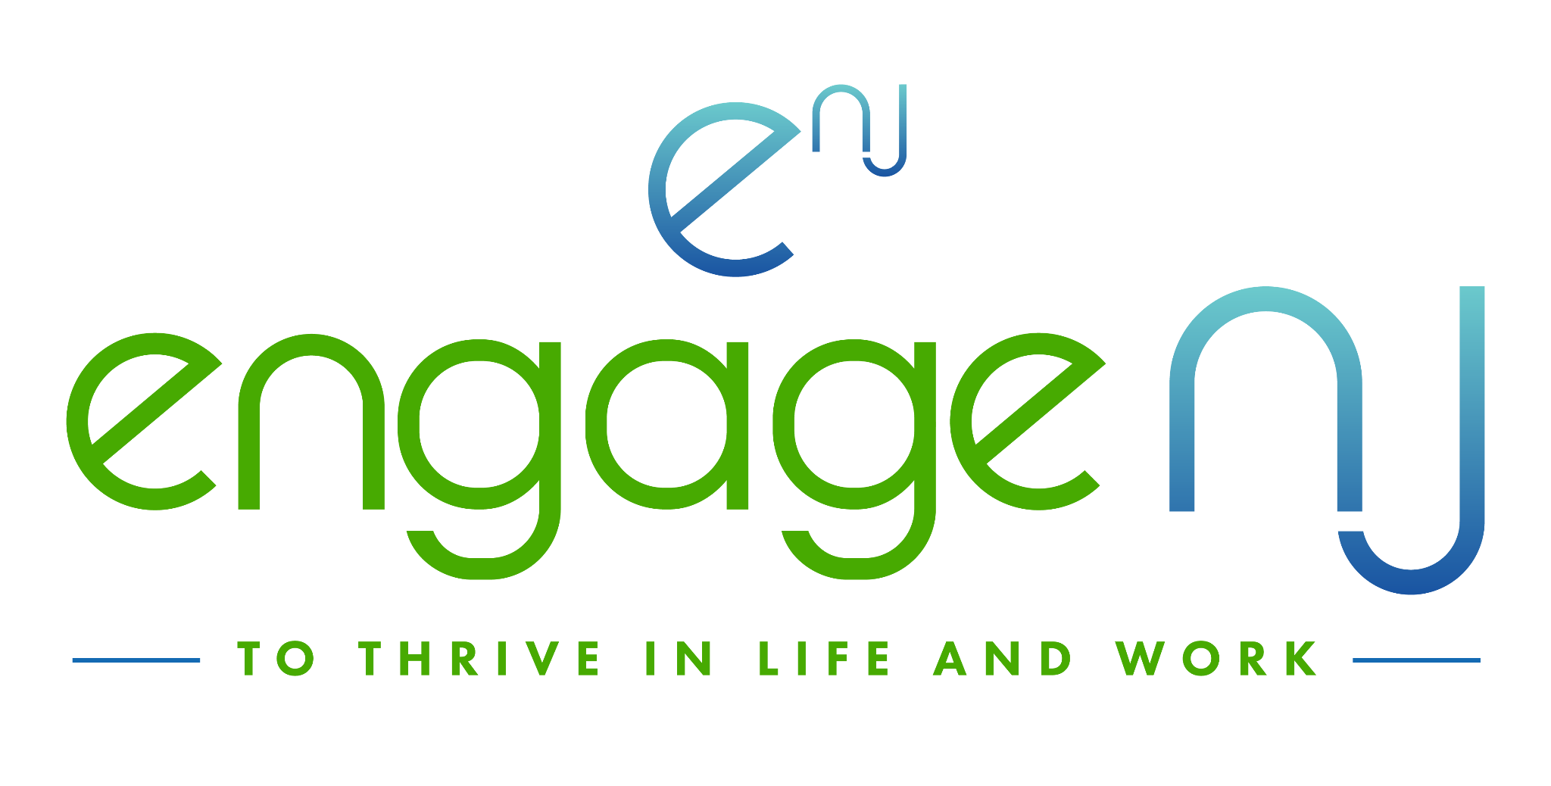

STATEWIDE

AMERICORPS VISTA Project
(Volunteers in Service to America)

HOST SITE APPLICATION GUIDANCE

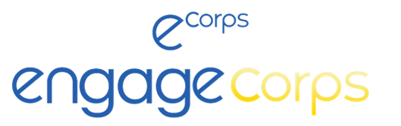

Application Part 1 Deadline: April 5, 2024
Application Part 2 Deadline: May 3, 2024

Contact Information:
Saul Petersen, Executive Director, Saul@EngageNJ.org
Destiny Rodriguez, Program Manager, Destiny@EngageNJ.org

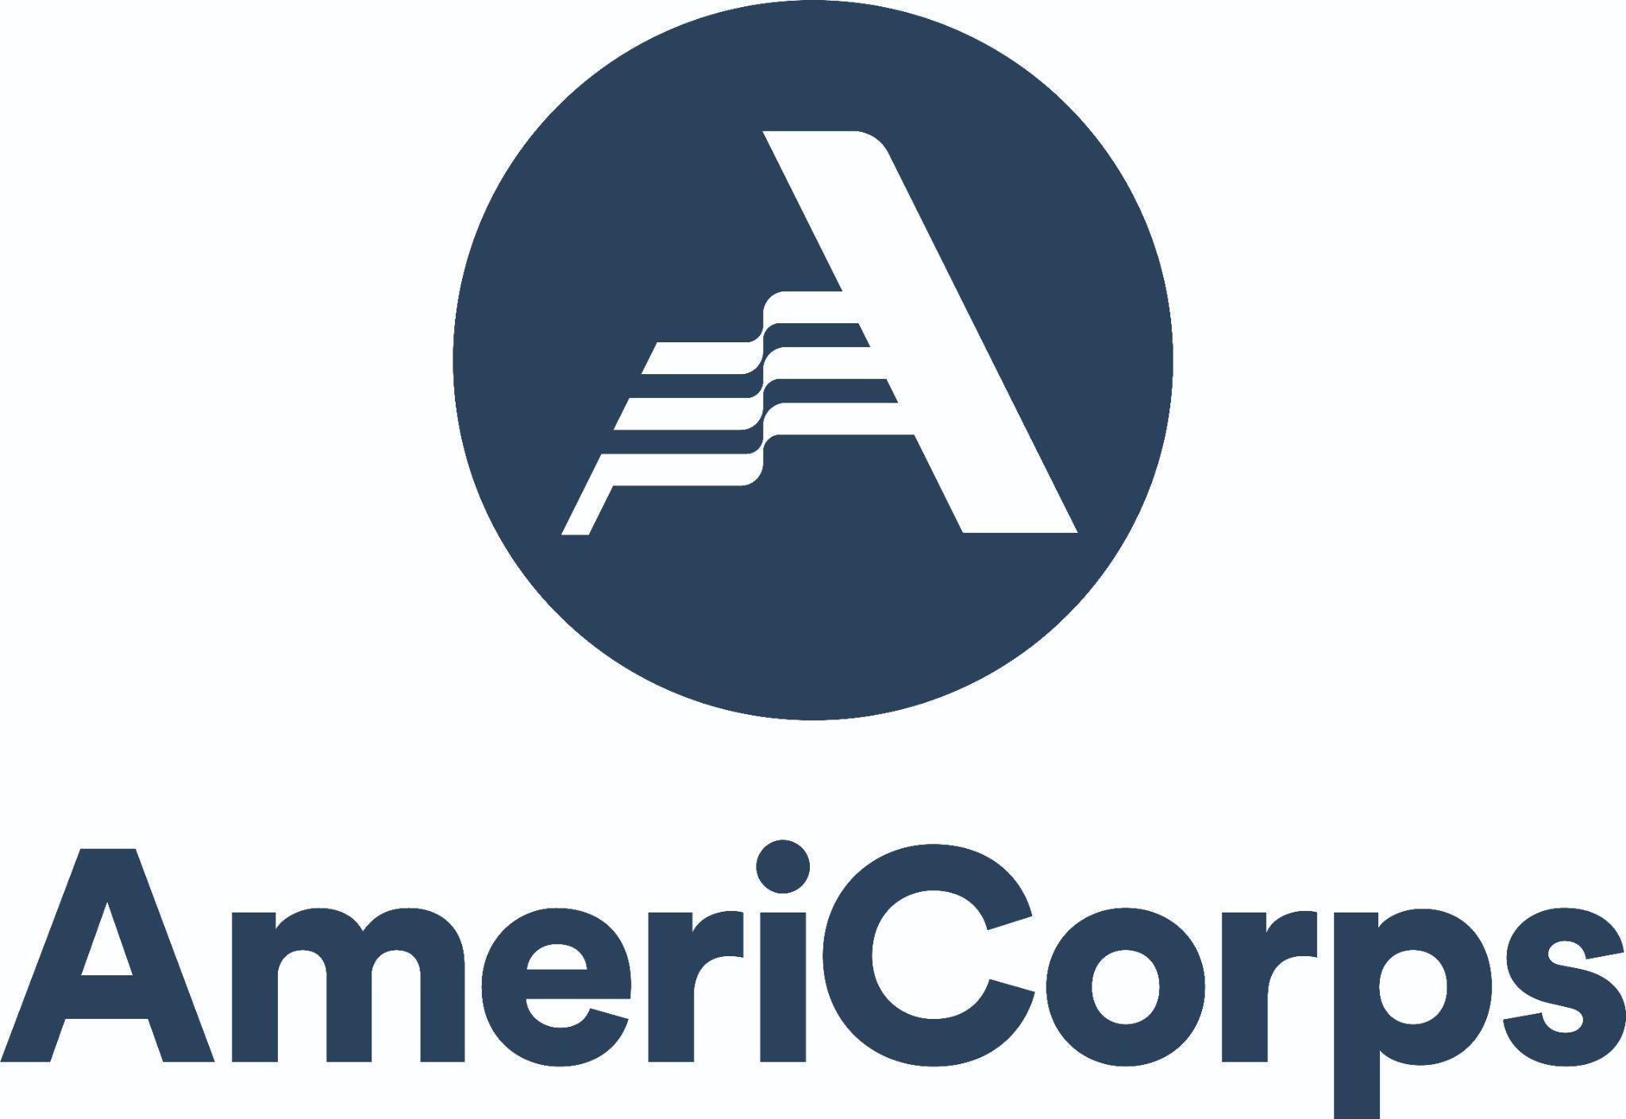
SPONSORED BY

Table of contents
Table of Contents 2
About Engage NJ 2
About ENGAGECorps VISTA Project 3
A.Capacity Builders: Increasing an Organization’s Effectiveness, Efficiency, and Program Reach 4
Key Elements of the Capacity Builders Program 4
B. Skill Builders: Developing Students’ 21st Century Skills for Life and Work 4
Key Elements of the Skill Builders Program 4
C. Community Resource Centers: Supporting Students’ Health and Food Security 4
Key Elements of the Community Resource Centers Program 4
D. Tutoring and Mentoring: Increasing High School Completion and College Access 5
Key Elements of the Tutoring and Mentoring Program 5
E. Environmental Stewardship: Supporting High School Climate Change Education Standards 6
Key Elements of the Environmental Stewardship Program 6
VISTA Supervision and Program Compliance 7
Sustainability 7
Host Site 7
Host Site Fee 7
Host Site Responsibilities 7
VISTA Enrichment 8
Data Collection 9
Our Partnership Policies on Recruitment and Retention 9
Engage NJ VISTA 9
AmeriCorps Member Benefits 9
2024 Timeline: Application, Onboarding, Reporting, & ‘24 Recruiting 10
Application Instructions 11
Additional Resource for VISTA Programs 11

About Engage NJ
Engage NJ is the only higher education presidents’ coalition focused on civic engagement across all higher education sectors. We equip and empower campuses to foster competencies that advance democracy and enable students to thrive in 21st-century life and work. We have a 10-year history of successfully managing multimillion-dollar AmeriCorps grants and, in early 2022, were awarded one of the largest AmeriCorps VISTA grants in New Jersey, focused on getting students to college, then through college, ready to thrive in their lives.

About ENGAGECorps VISTA Project
At the federal level, AmeriCorps VISTA is the national service program under the Federal Agency, the Corporation for National Community Service (CNCS), that works to eliminate poverty. Since 1965, over 220,000 VISTAs have joined the fight against poverty by helping local organizations expand their capacity to make change. All positions are pending federal budget and funding from CNCS.

Each VISTA makes a year-long, full-time commitment to serve with their specific project during their term of service. In return for their service, ENGAGECorps VISTAs receive a modest bi-weekly living allowance fixed at the poverty level in the county in which they serve and can receive healthcare benefits during their service. VISTAs can choose between a Segal Education Award (valued at $6,495) to pay for a range of education expenses or a $1,800 cash stipend once they have completed their service year. In addition, VISTA is the only AmeriCorps program that allows members to earn federal non-competitive eligibility, giving members an edge in the federal hiring process. VISTAs must be 18 years or older (no upper age limit), and hold one of the following citizenship or legal residency statuses: US citizen, US National, Lawful Permanent Resident (i.e. Green Card status), and persons legally residing within a state. Examples of persons legally residing within a state may include those holding the following classifications: refugee, asylee, temporary protected status throughout VISTA service, and Deferred Action for Childhood Arrivals (DACA) status. Visit here to learn more about the Federal VISTA program.

With the ENGAGECorps project here in New Jersey, VISTAs serve in an office setting and gain experience and leadership skills through capacity-building activities such as fundraising, grant writing, research, marketing, program development, and volunteer recruitment. As a function of the grant with CNCS, these capacity-building activities are laid out in a detailed VISTA Activity Description (VAD) that is equivalent to a position description developed by our partner sites in close collaboration with our team at Engage NJ. It is a step-by-step depiction of the activities the VISTA will need to perform within the partner site’s project to complete their service year. This opportunity prepares ENGAGECorps VISTAs with the skills and experiences to advance along their career journeys, while also developing an invaluable professional network of allies.

As a key component of our new 5-year plan, ENGAGECorps VISTAs in New Jersey will focus on
A. Capacity Builders: Increasing an organization’s effectiveness, efficiency, and program reach
B. Skill Builders: Developing college students’ 21st-century skills for life and work
C. Community Resource Centers: Supporting Students’ Health and Food Security
D. Tutoring & Mentoring: Increasing high school completion and college access
E. Environmental Stewardship: Supporting High School Climate Change Education Standards

A. Capacity Builders: Increasing an Organization’s Effectiveness, Efficiency, and Program Reach
EngageCorps VISTA can help expand the ability of sponsor organizations to fight poverty. Rather than providing services to low-income individuals and communities, VISTAs strengthen and support organizations by building infrastructure, expanding community partnerships, and securing long-term resources. VISTAs can help increase the organization’s effectiveness, efficiency, and reach by performing the following activities:

- Community Assessment
- Build Community Awareness & Engagement
- Expand/Strengthen Partnerships/Networks
- Develop and Expand Financial Resources
- Outreach
- Improve and Expand Material Development
- Volunteer Recruitment and Management

B. Skill Builders: Developing College Students’ 21st-century Skills for Life and Work
EngageCorps VISTAs can help organizations or career centers build 21-st century skills and job readiness. VISTAs can help develop and strengthen program development to increase knowledge or skills related to job seeking, obtaining, and retention by performing the following activities:

- Help students sharpen their skills for effective advocacy and activism
- Turn volunteer service and civic engagement into skills that set you up for a meaningful career
- Help students pitch their skills in communication, critical thinking, leadership, collaboration, goal setting, and more - through student civic engagement and volunteerism
- Develop Materials for Resume and Cover Letters and Interview Skill-Building Workshops, etc.
- Volunteer Management and Recruitment for workshops, mock interviews, resume review etc.
- Providing access to technological resources for applying to jobs, interviews, etc.

C. Community Resource Centers: Supporting Students’ Health and Food Security Overview of Community Resource Centers
Since 2018 here in New Jersey, we have piloted and then witnessed a growing number of community resource centers designed to link students with resources that empower and enhance self-determined success. Centers such as these include, but go beyond, building a food pantry. Each center caters to its distinct campus community but, overall, they strive to increase awareness of, and provide equal access to, resources such as those that address food and housing insecurity, nutrition and hygiene, access to professional clothing, mental health counseling, financial literacy tools, opportunities to volunteer on community projects with peers, and more. By working within the Engage NJ network of community resource centers and with the capacity-building support of a full-time VISTA, partners can expect to build the scale of your community center over several years and with important features.

Key Elements of the Community Resource Centers Program
It is important to develop your distinctive version of a community center where myriad supports and resources are availed of in a stigma-free and welcoming environment for all.

Welcoming
A welcoming community feel is crucial to all community center spaces. This means a conscious removal of stigmatization and labeling in the center’s design, marketing, and programs. Indeed, as opposed to students only accessing the center for things they need, we encourage a design and expectation that students in the Community Center are needed and active on campus and in neighboring communities in other volunteer and community engagement activities.

Comprehensive
Center staff should work to establish a comprehensive approach to student resource provision. These areas of comprehensive resource availability may include the following examples:

- Food and housing security
- Nutrition & Hygiene
- Community engagement

- Financial literacy tools
- Counseling and mental health
- Access to professional clothing

Cost-Effective
There are numerous strategies for compiling resources without needing to raise significant funds. By building bridges to offices across campus and to services brought in from neighboring businesses and services, the community center can provide robust programming and resources at a fraction of those required for centers outside of higher education. Partners in this network can learn about different ways of engaging students and faculty in community resource center spaces through various volunteer, community-engaged learning, or research projects. For example, students in a social work master’s program can run informal group counseling for students, perhaps as a pizza lunch event, and gain valuable practicum hours in the process. This was rolled out at minimal cost (for pizzas only) over the past few years at a partner campus, New Jersey City University, with great success.

Network Development
VISTAs can work across the network to share replicable ideas and successes such as using community-engaged learning (service learning) to tackle specific community center projects. NJCU, for example, utilized two faculty working together on a CEL project to design and develop a KIOSK for students.

VISTAs can act on opportunities and challenges the network raises at regular events, such as creating weekend backpacks of food to bring home to family members. VISTAs in this cohort will gain from collaboration, sharing best practices, and proactive methods of avoiding actions that inadvertently stigmatize students and community members.

D. Tutoring and Mentoring: Increasing High School Completion and College Access
ENGAGECorps VISTAs can help to expand or deepen the impact of tutoring and mentoring programs designed to increase high school completion and college access.

Key Elements of the Tutoring and Mentoring Program
The VISTA member will support current campus efforts to build those bridges of success from neighboring high schools to your campus. Many high schools that serve systematically excluded students are struggling to get as many of their students as in previous years to graduate and go to college, based on feedback and enrollment figures, especially at minority-serving institutions. Covid, layered on top of pre-existing barriers to successful engagement and completion, is taking its toll on the numbers attending college.

Increase Persistence, Graduation, and College Access
The goal of this VISTA project is to build the capacity of your tutoring and mentoring programs in neighboring high schools that, ultimately, will contribute to the size of graduating cohorts and many high school graduates who are ready for and believe in the value of a college education. VISTAs can, for example:

- Work on designing elements of your program such as curriculum and events
- Work heavily on volunteer recruitment and management
- Help with fundraising campaigns and drives as needed for such things as transportation, materials, and events
- Get together regularly for professional development and to learn from one another.
Ultimately, the aim for VISTAs is to increase the capacity of your mentoring and tutoring
to work with as many high school students as possible to persist, graduate, and go to college.

E. Environmental Stewardship: Supporting High School Climate Change Education Standards
New Jersey is the first state to adopt climate change education standards across the K-12 curriculum. This is brand new, and society’s youth have not yet had the experiences to think about and critique how climate change is narrowing their life choices. Coupled with the challenging choices many students are facing as Covid pushes many highschoolers out of school and into poorly paid work, we must act with urgency to provide knowledge, experience, and hope to the next generation of public servants, executives, and influencers, many of whom will take their new high school degree and look for postsecondary pathways to becoming an informed citizen and to considering various “green” careers.

Key Elements of This Climate Change Education Cohort

Expanding the Capacity of Existing Higher Ed-High School Partnerships
ENGAGECorps VISTAs work with faculty, staff, and students, to enhance partnerships with local high schools aimed at helping teachers and high school students learn about standards-focused curriculum on climate change.

These partnerships will provide meaningful civic and climate experiences in the process. VISTAs can, for example:

- Work within existing campus-high school partnerships, such as through sustainability and education majors, to bring college students into high school classrooms and field trips to deliver project-based support to teachers in adopting the new standards
- Provide, as needed, best practices to faculty to adapt their courses into CEL to connect their course objectives to high school classes, bringing their students into high school classrooms for mutually beneficial experiences

Provide Training, Licenses and Curriculum to VISTAs and Teachers on Climate Education

PLEASE NOTE: The following resource for this cohort with SEIinc is contingent on being awarded additional funding due to added costs incurred.

Engage NJ is building a partnership with nationally recognized leader, SEIinc., to train ENGAGECorps members to support high school teachers with proven methods and with standards-aligned sustainability curricula to meet the new standards – how to access project-based curricula, and how to bring them into different high school grades and subjects. With the additional funding, both SEI and ENGAGECorps members will provide ongoing hands-on time and support to teachers.

VISTA Supervision and Program Compliance

Sustainability
AmeriCorps VISTA resources are usually provided based on a multi-year grant cycle. From year to year, the Corporation for National and Community Services expects that the objectives and activities of the VISTA will evolve. Applicants should have a sound concept of how the resources and progress furnished by the VISTA will be sustained by the organization. VISTAs are an extension of an organization's efforts to support and empower a community.

Host Site
The host site is a non-profit organization or college/university that will host the VISTA for the duration of the service year. Each VISTA is guided by the workplace policies of their host sites — requesting leave, hours of operations, ADA compliance, etc. Each host site is expected to provide a VISTA with the necessary office space, equipment, and access to all items needed for the successful completion of the service term. Our hosts often collaborate to see to the success of the project and to provide the best suitable service experience for the VISTA.

Host Site Fee
The host site is responsible for the program fee to Engage NJ, to assist with training and support of the VISTA member. All host sites must pay a “host site fee” to Engage NJ to assist with these costs. For the 2024-2025 program year, the host site fee will be $12,000 per VISTA member for the partner campus.Non-member campus and nonprofit host site fees will be $14,000 per VISTA member or $12,000 per VISTA member + $2,000 to be a member of Engage NJ. All host site fees are non-refundable.

Host sites providing a housing stipend will increase the likelihood of attracting quality VISTA applicants and will aid in retaining the VISTA throughout the program year. If the program or organization can provide housing for free, that will drastically increase VISTA interest in a particular host site.

Host Site Responsibilities
Host sites are required to perform local recruitment for their assigned AmeriCorps VISTA placement. This includes posting the position, screening, interviewing, and submitting the locally recruited candidate to Engage NJ once identified. Engage NJ will let AmeriCorps know of the selected candidate. Parallel to local recruitment by the host sites, Engage NJ will perform a state-wide recruitment looking for talent applicable to position descriptions. Engage NJ will prescreen applicants and contact the host sites that seem to be a good match. Engage NJ will interview selected candidates, check references, and submit the candidate to AmeriCorps for approval. Supervision

The Supervisor ensures that every VISTA has the right conditions and requirements to perform their service, including a full understanding of the project’s mission, goals, and vision, as well as a solid understanding of the community they are serving.

Depending on the site's capacity, the site may have both a Site Supervisor and a day-to-day supervisor for the VISTA. All sites are required to have a site supervisor. Supervision of the VISTAs requires dedication of time and resources aside from the supervision of the project itself. VISTA Site Supervisors are expected to meet with their VISTA on a routine, weekly basis to further the VISTA project. VISTA Supervision may require anywhere from 5-10 hours a week depending on the intensity of the program and the point of service. For example, within the first quarter of service during onboarding and acclimation to the site, the site supervisor would need to dedicate at least 10 hours a week to ensure that the VISTA has all the resources needed for the project's success.

Site Supervisors must ensure that VISTAs have a host site, workspace, and access to all office materials needed for the service year. Day-to-day supervisors may assist in ensuring that the VISTA has all necessary resources and also understands HR policies as they relate to the host site. All VISTA supervisors (site supervisors and day-to-day supervisors) are required to attend site supervisors training. VISTA supervisors are also expected to assist and provide training and enrichment opportunities for their VISTAs. Site Supervisors should be dedicated to the growth of the VISTAs by providing ample context and access to networks and maintaining open, candid, communication with us. Communication with Engage NJ will include email correspondence with reasonable turnaround times as well as bi-monthly conference calls with the supervisory cohort of the ENGAGECorps VISTA project.

Site Supervisor Responsibilities:
- Monitors VISTA performance
- Completes all data reports (monthly and quarterly reports on schedule
- Assigns tasks for successful completion of the VAD
- Attend site supervisors training
- Point of contact for Engage NJ and VISTA
- Meets with VISTA weekly

Day-to-Day Supervisor Responsibilities:
- Monitors the day-to-day activity of VISTA
- Assigns VAD-related tasks
- Attends site supervisor training
- Monitors attendance/HR-related policies
- Communicates with Engage NJ and VISTA members
- Meets with VISTA members on a routine, weekly basis
- May assist with completion of Monthly and Quarterly report

VISTA Enrichment
AmeriCorps VISTAs volunteer to live at the poverty level for an entire year while serving full time. We aim to provide additional support and development opportunities outside of the VISTA members’ routine activities. Applicants are encouraged to list all benefits they intend to provide a VISTA (i.e. housing, meal plans, access to free classes/training, professional development, access to fitness center, transportation passes, etc.). These details further recruitment and retention.

Data Collection
Quarterly, VISTA members complete an Engage NJ report that covers what activities have been accomplished, any challenges VISTAs faced, training needs, and tracking the VISTA members’ progress. The Quarterly Reports serve as a way to collect AmeriCorps and grant requirement performance measures for the VISTA program. A six-month progress report and end-of-year sustainability report must be completed by each VISTA member to assist with Engage NJ’s reporting to AmeriCorps. Engage NJ works with sites to track outputs and outcomes of the VISTA project. Those quarterly reports will be collected and combined to create reports to be submitted to AmeriCorps on the progress of the project.

Our Partnership Policies on Recruitment and Retention
Engage NJ aims to maintain a cohort that will function as one. We will work with each site to do our due diligence in retaining all of our VISTA members. Please note the following retention policies:

- Recruitment deadlines must be strictly adhered to. Sites that have not chosen a VISTA member to assign to their project by the July 1 deadline may have to reapply for a VISTA in the next service year.

- VISTA members will not be permitted to serve on location at their host site until the Partner Site Fee has been paid in full.

- If a member voluntarily ends their service or is terminated within the first 30 days from the first day of On-Site Orientation and Training (OSOT) in August, we will look to replace the member immediately so they can remain on track with the cohort. Following the first 30 days, we will not be in a position to recruit a replacement VISTA.

- In the case of the VISTA no longer serving at the site during the first six months of service - whether due to resignation or termination - the $11,000 partner fee is 50% refundable. Following six months of service, should the VISTA no longer serve at the site for any reason, the $10,000 fee is nonrefundable.

- We are implementing stringent guidelines for the accountability of sites and site supervisors. Guidelines include interventions for non-compliance by sites, for example, sites requiring VISTA members to perform service outside of the VAD, and late submission of reporting data. These will be reviewed in full during the Supervisor's orientation in July.

Engage NJ VISTA
During a VISTA member’s year of service, each member will receive professional development, help host our THRIVE Student Conference, and be responsible for reporting and other tasks from Engage NJ that will add to their full-time service hours.
- Engage NJ VISTA members vary in age and come from a variety of diverse backgrounds and experiences.
- A year of national service is regarded as a full-time placement requiring a minimum of 37.5 hours of service each week
- Most VISTAs have graduated from a two or four-year college degree program
- The minimum age requirement to serve as a VISTA is 18 years old

AmeriCorps Member Benefits
During a VISTA member’s year of service, each member receives a monthly stipend, support, and benefits from AmeriCorps. Those benefits include:
- Living Stipend based on county-serving
- End of Service Award - Education Award $7,395 or Cash Stipend $1,800
- Healthcare Assistance
- Child Care Assistance
- Relocation or Settling in Allowance (if moving more than 50 miles)

2024 Timeline: Application, Onboarding, Reporting, & ‘24 Recruiting

By April 5 Applications submitted (NOTE: Earlier completion of application can enhance recruitment due to seniors graduating in May;
Recruitment - Engage NJ and Partners Advertise Positions (pending final approval of position descriptions by funder);
Detailed VADs completed (important step for interviewing and required by funder)

April - June Screening, interviewing, and selecting candidates;
Partner fee invoices released upon selection of the candidate(s)

July 1 Deadline for sites to select candidates and candidates to accept positions

July TBD Orientation for Supervisors of ENGAGECorps VISTAs;
Supervisors sign MoU

August Sites prepare office and project timelines for VISTA

W/O August 21st VISTA members attend virtual federal virtual member orientation (VMO) and
Engage NJ on-site orientation (OSOT)

August 30 Start Date at Partner Site

Reporting Quarterly, beginning October 2024

Training Bi-monthly virtual and in-person; includes Linked In Learning (licensed with Engage

Application Instructions
The application is in the form of a Google Sheet or Excel Document and will be emailed to you after completing the partner site interest form. There are 5 sections or tabs that create the completed application.

Partner Site Interest Form

PART A: Applicant and Project Information (tabs 1 and 2 of the application)
Instructions and Deadline: Please complete by April 5, 2024

Applicant Information and Project Information is gathered to learn more about your organization and proposed project. Using the Project Information tab, you will create an opportunity listing that will be used for recruiting purposes.

Purpose: The form submitted by applicants provides the information needed for Engage NJ to jointly develop a VISTA Project that will be approved by the AmeriCorps federal funders. Additionally, these documents reflect the records CNCS requires Intermediary Agents (Engage NJ) to maintain.

Incomplete Submission: Upon receipt and review of the documents, and following a request for missing documents, Engage NJ may have to remove the applicant from consideration for the 2024-2025 Grant Cycle for incomplete submissions. Applicants will be notified of incomplete submissions within three business days of their submission date and will have 72 hours to submit missing materials before being removed from consideration.

PART B: Narratives, Service Activities, and VISTA Position Description (tabs 3, 4, and 5 of the application)
Instructions and Deadline: Please complete by May 3, 2024

You will use the Service Activities tab as a reference to create the federally required VISTA Activity Description (VAD) for each VISTA member at your site. The VAD serves as a detailed description of activities the federal government will approve as the performance measures the VISTA and program will meet over the year. The VAD must also be submitted by May 3, 2024. We will then review and submit the VAD to our federal funders for approval.

Additional Resource for VISTA Programs

Key VISTA Facts
VISTA Benefits
VISTA Stipend Rate

--- FINAL PAGE —

